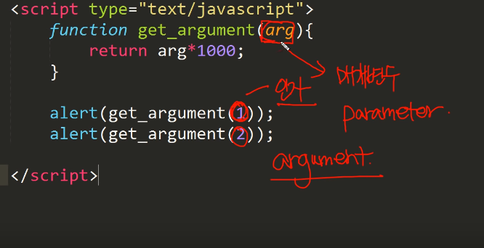

매개변수와 인자, argument and parameter are completely different names but people these days often use these two words with the same purpose. Parameter is a value used inside a function, argument is a inputted parameter value to a function.

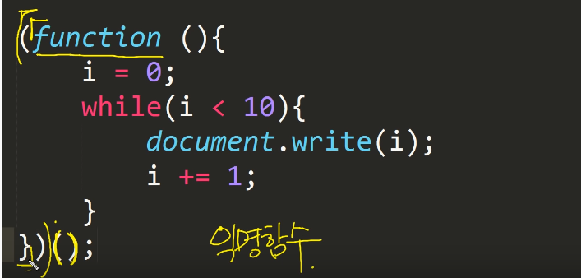

익명함수, 익명객체처럼 일회성 사용시 사용한다.

var grades = {}; or var grades = new Object {};